NOR-SOLIDARITY DMC report
Inge Christoffer Olsen, PhD
17 October, 2020

Introduction
This is the report for the first Data Monitoring Committee meeting in the NOR-SOLIDARITY trial. The data are based on an export from the Viedoc electronic data capture system time stamped 28 April 2020 13:49 UTC. There were 185 included patients.

Inclusion status

Inclusion rate
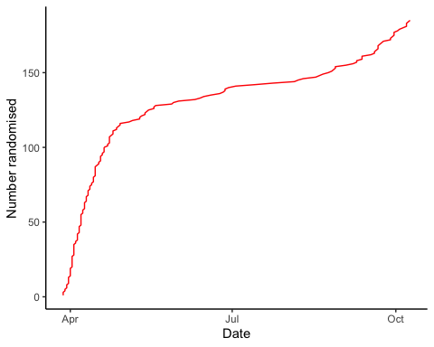

Inclusion by hospital
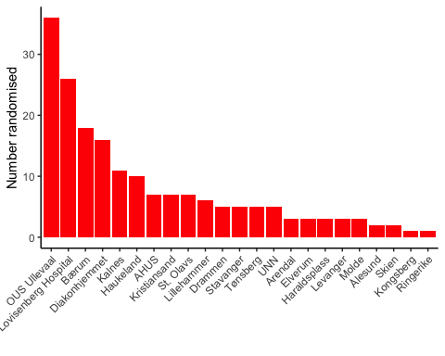

By treatment
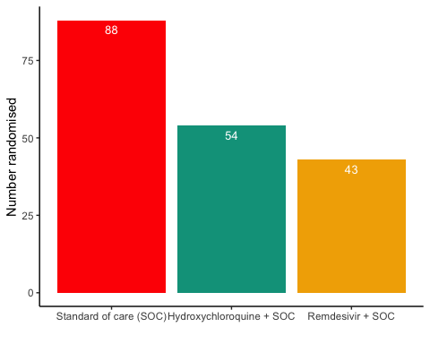

Demographics
Demographics
Parameter
SOC (N=88)
SOC + HCQ (N=54)
SOC + Remdesivir (N=43)
Age (years)
59.3 (16.1)
60.3 (13.8)
60 (16.4)
Female, n (%)
28 (31.8%)
21 (38.9%)
13 (30.2%)

Exposure
Exposure to study treatment
Parameter
Hydroxychloroquine + SOC
Remdesivir + SOC
Total dose, median (IQR), mg
5200 (3600 - 8400)
700 (500 - 1100)
Days with treatment, median (IQR)
6 (4 - 10)
6 (4 - 10)
Patients with any treatment discrepencies, n (%)
23 (42.6%)
11 (25.6%)

Adverse Events

AE Summary
Summary of Adverse Events
Parameter
SOC (N=88)
SOC + HCQ (N=54)
SOC + Remdesivir (N=43)
Number of AEs
[31] 20 (22.7%)
[34] 20 (37%)
[26] 16 (37.2%)
Number of patients with any AEs?
20 (22.7%)
20 (37%)
16 (37.2%)
Number of patients with one AE
13 (14.8%)
14 (25.9%)
11 (25.6%)
Number of patients with two AE
3 (3.4%)
2 (3.7%)
1 (2.3%)
Number of patients with three or more AEs
4 (4.5%)
4 (7.4%)
4 (9.3%)
Number of SAEs
[18] 11 (12.5%)
[13] 8 (14.8%)
[12] 10 (23.3%)
Number of patients with any SAEs?
11 (12.5%)
8 (14.8%)
10 (23.3%)
The numbers are [Number of events] Number of patients (percentage of patients), or Number of patients (percentage of patients)

By System Organ Class and Preferred Term
Adverse Events by System Organ Class and Preferred term
System Organ Class
Preferred Term
SOC (N=88)
SOC + HCQ (N=54)
SOC + Remdesivir (N=43)
Blood and lymphatic system disorders
#Total
[2] 1 (1.9%)
Leukopenia
[1] 1 (1.9%)
Thrombocytopenia
[1] 1 (1.9%)
Cardiac disorders
#Total
[1] 1 (1.1%)
[3] 2 (4.7%)
Arrhythmia
[2] 1 (2.3%)
Ventricular tachycardia
[1] 1 (1.1%)
[1] 1 (2.3%)
Gastrointestinal disorders
#Total
[2] 2 (2.3%)
[4] 4 (7.4%)
[4] 3 (7%)
Abdominal pain
[1] 1 (1.1%)
Diarrhoea
[1] 1 (1.1%)
Diarrhoea haemorrhagic
[1] 1 (2.3%)
Gastrooesophageal reflux disease
[1] 1 (1.9%)
Intestinal pseudo-obstruction
[1] 1 (1.9%)
Nausea
[2] 2 (4.7%)
Pancreatic failure
[1] 1 (1.9%)
Vomiting
[1] 1 (1.9%)
[1] 1 (2.3%)
General disorders and administration site conditions
#Total
[3] 3 (3.4%)
[2] 2 (4.7%)
Chest pain
[1] 1 (2.3%)
General physical health deterioration
[1] 1 (1.1%)
Medical device site reaction
[1] 1 (2.3%)
Pyrexia
[2] 2 (2.3%)
Infections and infestations
#Total
[3] 3 (3.4%)
[1] 1 (1.9%)
COVID-19
[1] 1 (1.9%)
Infection
[1] 1 (1.1%)
Pneumonia bacterial
[2] 2 (2.3%)
Investigations
#Total
[5] 3 (3.4%)
[10] 6 (11.1%)
[4] 4 (9.3%)
Alanine aminotransferase increased
[2] 1 (1.1%)
[2] 2 (3.7%)
Amylase increased
[1] 1 (1.9%)
Aspartate aminotransferase increased
[1] 1 (1.1%)
[3] 3 (5.6%)
[1] 1 (2.3%)
Blood creatine phosphokinase increased
[1] 1 (1.9%)
Electrocardiogram QT prolonged
[2] 2 (3.7%)
Fibrin D dimer increased
[1] 1 (1.1%)
Gamma-glutamyltransferase increased
[1] 1 (1.9%)
Hepatic enzyme increased
[2] 2 (4.7%)
Myocardial necrosis marker increased
[1] 1 (1.1%)
Neutrophil count decreased
[1] 1 (2.3%)
Metabolism and nutrition disorders
#Total
[1] 1 (1.9%)
Hypercalcaemia
[1] 1 (1.9%)
Musculoskeletal and connective tissue disorders
#Total
[4] 2 (3.7%)
Arthralgia
[1] 1 (1.9%)
Arthritis reactive
[1] 1 (1.9%)
Joint swelling
[1] 1 (1.9%)
Tendonitis
[1] 1 (1.9%)
Neoplasms benign, malignant and unspecified (incl cysts and polyps)
#Total
[1] 1 (1.1%)
Neoplasm malignant
[1] 1 (1.1%)
Nervous system disorders
#Total
[1] 1 (1.1%)
[1] 1 (1.9%)
[2] 2 (4.7%)
Headache
[1] 1 (2.3%)
Loss of consciousness
[1] 1 (2.3%)
Syncope
[1] 1 (1.1%)
[1] 1 (1.9%)
Renal and urinary disorders
#Total
[1] 1 (1.1%)
[1] 1 (1.9%)
Renal failure
[1] 1 (1.1%)
[1] 1 (1.9%)
Respiratory, thoracic and mediastinal disorders
#Total
[8] 6 (6.8%)
[9] 7 (13%)
[7] 5 (11.6%)
Bronchopleural fistula
[1] 1 (2.3%)
Chronic obstructive pulmonary disease
[2] 1 (2.3%)
Cough
[1] 1 (1.1%)
Dyspnoea
[3] 1 (1.1%)
[1] 1 (2.3%)
Pulmonary embolism
[1] 1 (1.9%)
Respiratory distress
[3] 3 (3.4%)
[4] 3 (5.6%)
Respiratory failure
[1] 1 (1.1%)
[4] 4 (7.4%)
[3] 2 (4.7%)
Skin and subcutaneous tissue disorders
#Total
[1] 1 (2.3%)
Alopecia
[1] 1 (2.3%)
Vascular disorders
#Total
[1] 1 (1.1%)
[1] 1 (1.9%)
[1] 1 (2.3%)
Hypotension
[1] 1 (2.3%)
Thrombophlebitis
[1] 1 (1.9%)
Thrombosis
[1] 1 (1.1%)

Serious Adverse Events
Serious Adverse Events by System Organ Class and Preferred term
System Organ Class
Preferred Term
SOC (N=88)
SOC + HCQ (N=54)
SOC + Remdesivir (N=43)
Gastrointestinal disorders
#Total
[1] 1 (1.1%)
[1] 1 (2.3%)
Abdominal pain
[1] 1 (1.1%)
Diarrhoea haemorrhagic
[1] 1 (2.3%)
General disorders and administration site conditions
#Total
[2] 2 (2.3%)
[1] 1 (2.3%)
Chest pain
[1] 1 (2.3%)
General physical health deterioration
[1] 1 (1.1%)
Pyrexia
[1] 1 (1.1%)
Infections and infestations
#Total
[1] 1 (1.1%)
[1] 1 (1.9%)
COVID-19
[1] 1 (1.9%)
Pneumonia bacterial
[1] 1 (1.1%)
Investigations
#Total
[1] 1 (1.1%)
[2] 2 (3.7%)
[2] 2 (4.7%)
Alanine aminotransferase increased
[1] 1 (1.1%)
Aspartate aminotransferase increased
[1] 1 (1.9%)
Blood creatine phosphokinase increased
[1] 1 (1.9%)
Hepatic enzyme increased
[2] 2 (4.7%)
Neoplasms benign, malignant and unspecified (incl cysts and polyps)
#Total
[1] 1 (1.1%)
Neoplasm malignant
[1] 1 (1.1%)
Nervous system disorders
#Total
[1] 1 (2.3%)
Loss of consciousness
[1] 1 (2.3%)
Renal and urinary disorders
#Total
[1] 1 (1.1%)
[1] 1 (1.9%)
Renal failure
[1] 1 (1.1%)
[1] 1 (1.9%)
Respiratory, thoracic and mediastinal disorders
#Total
[7] 5 (5.7%)
[9] 7 (13%)
[7] 5 (11.6%)
Bronchopleural fistula
[1] 1 (2.3%)
Chronic obstructive pulmonary disease
[2] 1 (2.3%)
Dyspnoea
[3] 1 (1.1%)
[1] 1 (2.3%)
Pulmonary embolism
[1] 1 (1.9%)
Respiratory distress
[3] 3 (3.4%)
[4] 3 (5.6%)
Respiratory failure
[1] 1 (1.1%)
[4] 4 (7.4%)
[3] 2 (4.7%)

Suspected Unexpected Serious Adverse Reaction
Suspected Unexpected Serious Adverse Reaction by System Organ Class and Preferred term
System Organ Class
Preferred Term
Remdesivir + SOC
Gastrointestinal disorders
#Total
[1] 1 (2.3%)
Diarrhoea haemorrhagic
[1] 1 (2.3%)

Outcome
The following report is based on pseudo-randomised groups, not true allocations. The true allocations are available for the DMC only.
Outcome
Parameter
SOC (N=88)
SOC + HCQ (N=54)
SOC + Remdesivir (N=43)
Alive and discharged
77 (87.5%)
46 (85.2%)
37 (86%)
Withdrawn
1 (1.1%)
2 (3.7%)
3 (7%)
Ongoing
2 (2.3%)
4 (7.4%)
1 (2.3%)
Dead
8 (9.1%)
2 (3.7%)
2 (4.7%)

